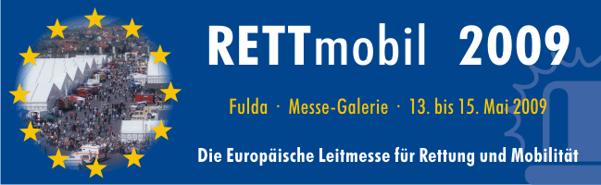

You are cordially welcomed to the 9th RETTmobil (Mobile Rescue) 13 -15th May, 2009 - Come and join the 2009 EMS Safety Foundation delegation and experience all that RETTmobil has to offer in Fulda Germany, the European event for state of the art rescue and mobility. The philosophy, consisting of the three columns: Trade fair, Congress and Training/transport exercises. It is a unique concept, the attendees consist of the entire spectrum of the emergency service.

RETTmobil is the event for information and further training of emergency service personnel of the as well as of leaders and field rescuers. More than 300 exhibitors, and 20,000 visitors from throughout Europe and internationally were at the past RETTmobil event in May 2008. Many possibilities to experience, modern technology, innovative products, practical services, 70,000 square meter of exhibition sites, as well as test tracks in the heavy area in an off-road course on an additional 50,000 square meter large open areas. A congress, occupied with experts, of everything that the industry worked on and to new products to offer has. Since RETTmobil began in 2001 started those as modest industry fair. Today, within 8 years, the industry fair became the guidance fair across Europe’s borders and beyond

RETTmobil today is a platform for innovations internationally, to the most diverse technical topics from emergency service, medicine, organization and logistics.. The requirements at the emergency measures and the fire and disaster control become ever more complex. Explore these innovations with thousands other specialized visitors from throughout Europe and internationally, at the 9th RETTmobil of 13th to 15th May 2009 in the center Germany, in Fulda (Hessen) just outside of Frankfurt. Here you will meet many colleagues, bring your own experiences, deepen existing knowledge, test products and become acquainted with the newest innovations. English is spoken extensively throughout the RETTmobil event.

For more information:
.
EMS Safety Foundation Member Delegate Interest Form- Member RETTmobil Delegate Form
General Interest Form for non-Members and potential Corporate Sponsors - General Interest Form
RETTmobil Web site - http://www.rettmobil.com/
Translated RETTmobil Web site - English translation of RETTmobil Web Site
